EXP 03 – P.Malreddy (192372015)
Develop a flowchart in Figma depicting the operation of a Network Switching Subsystem in a mobile cellular system.

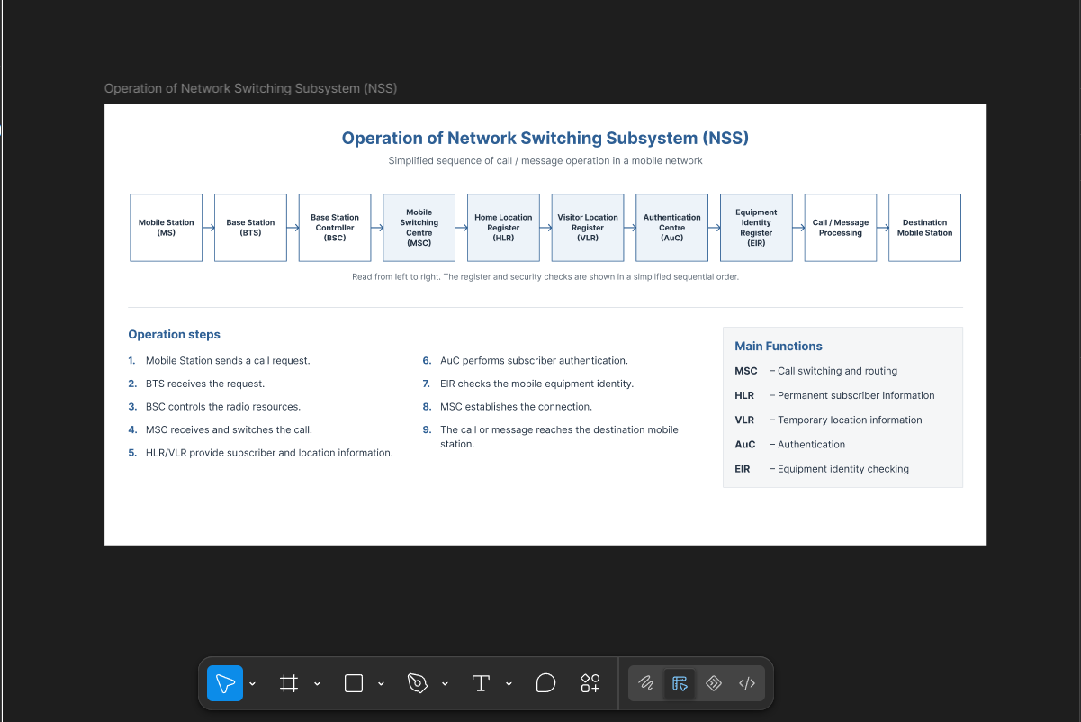

https://www.figma.com/design/wUneMbCcqDt84FFKy5QxTS/EXP-03?node-id=0-1&p=f&t=QcWTR6D5M9skhWHX-0

